Strawberry Mink Creek Water Association Operation and Maintenance Manual
2015
PWS # ID6210017
Table of Contents

- Description of System
- Board of Directors
- Licensed Operator
- Spring Information
- Chlorination Information
- Distribution Information
- System Maps
- Site Sampling Plan / Monitoring Schedule
- Emergency Response Plan
- Backflow Ordinance

System Description

Strawberry Mink Creek Water Association is a community water system located in Franklin County. The Association serves 33 connections. The water system is comprised of a spring, overflow box, chlorination building and approximately ???? miles/feet of mainlines.

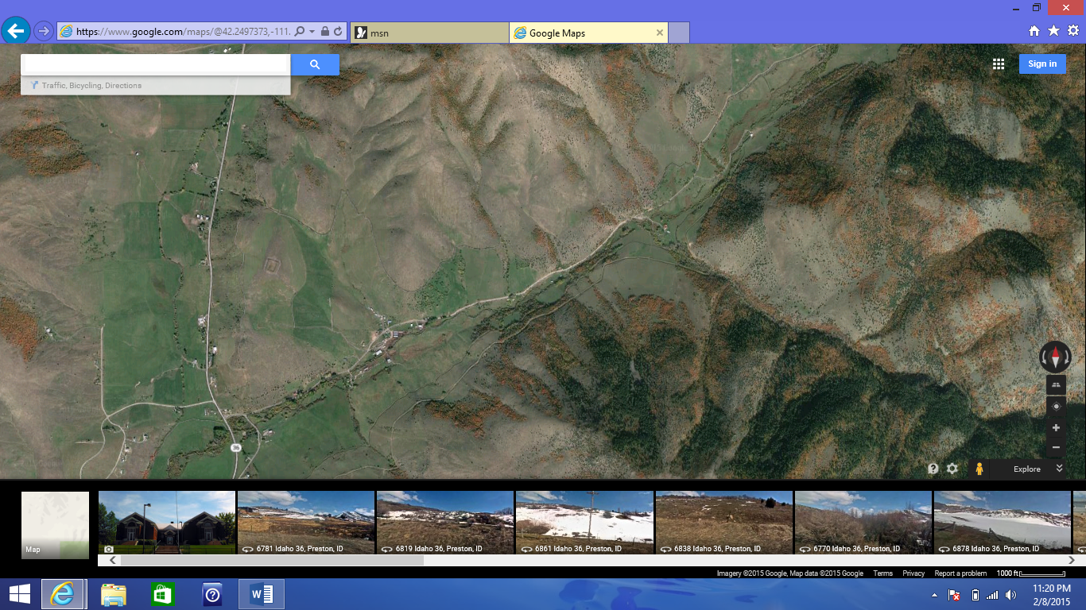

Board of Directors

Board President –
Board Member –
Board Member –
Board Member –
Secretary/Treasurer –

Licensed Operator

Public Record
Name:
Profession:
Type:
Number:
Address Of Record:
City/State/Zip:
Country:
Business Phone:
Original Date of Issue:
Registered/Licensed By:
Status:
Discipline Status:
Expiration Date:

Disciplinary Action Documents
None

Monitoring Schedule

The water system’s monitoring schedule is available on line at http://www.deq.idaho.gov/water-quality/drinking-water/pws-switchboard.aspx

DEQ Public Drinking Water System
Monitoring Schedule Report
Print Date: February 8, 2015

ID6210017 - STRAWBERRY MINK CREEK WATER ASSN
Community water system serving 75 people and 33 connections.
Regulated by POCATELLO REGIONAL OFFICE.
The following schedules include monitoring periods between 1/1/2015 and 12/31/2023.

Schedules for Distribution System(s)
 |  |  | Season | Season
Code | Group/Analyte Name | Monitoring Frequency | Begin Date | End Date | Satisfied
3100 | COLIFORM (TCR) | 1 per MN | 1/1 | 12/31 | Monthly
PBCU | LCR - LEAD COPPER | 5 per 3Y due in 2017  taken June through September | 6/1 | 9/30 | *FUTURE
PBCU | LCR - LEAD COPPER | 5 per 3Y due in 2020  taken June through September | 6/1 | 9/30 | *FUTURE
PBCU | LCR - LEAD COPPER | 5 per 3Y due in 2016  taken June through September | 6/1 | 9/30 | *FUTURE
DBP2 | DBP2-STAGE 2 | 1 per 3Y due in 2016  taken July through September | 7/1 | 9/30 | *FUTURE
 |  | 1 set TTHM/HAA5 - 7007 E HWY 36 (DBP2A)
DBP2 | DBP2-STAGE 2 | 1 per 3Y due in 2019  taken July through September | 7/1 | 9/30 | *FUTURE
 |  | 1 set TTHM/HAA5 - 7007 E HWY 36 (DBP2A)
DBP2 | DBP2-STAGE 2 | 1 per 3Y due in 2022  taken July through September | 7/1 | 9/30 | *FUTURE
 |  | 1 set TTHM/HAA5 - 7007 E HWY 36 (DBP2A)

Schedules for SPRING, Tag # E0007200
Please label these samples as 'SPRING'
 |  |  | Season | Season
Code | Group/Analyte Name | Monitoring Frequency | Begin Date | End Date | Satisfied
R226 | RADS - RADIUM 226 | 1 per 9Y due between 01/01/2008 and 12/31/2016 | n/a | n/a | NO
R228 | RADS - RADIUM 228 | 1 per 9Y due between 01/01/2008 and 12/31/2016 | n/a | n/a | NO
SODI | IOC - SODIUM | 1 per 3Y due between 01/01/2014 and 12/31/2016 | n/a | n/a | NO
SODI | IOC - SODIUM | 1 per 3Y due between 01/01/2017 and 12/31/2019 | n/a | n/a | *FUTURE
SODI | IOC - SODIUM | 1 per 3Y due between 01/01/2020 and 12/31/2022 | n/a | n/a | *FUTURE
URAN | RADS - URANIUM | 1 per 9Y due between 01/01/2008 and 12/31/2016 | n/a | n/a | NO
VOCS | VOCS - GROUP | 1 per 6Y due between 01/01/2014 and 12/31/2019 | n/a | n/a | NO
ZARS | ARSENIC (1005) | 1 per 9Y due between 01/01/2011 and 12/31/2019 | n/a | n/a | NO
ZFLU | IOC - FLUORIDE | 1 per 9Y due between 01/01/2011 and 12/31/2019 | n/a | n/a | NO
ZIOC | IOCS - PHASE 2 AND 5 | 1 per 9Y due between 01/01/2011 and 12/31/2019 | n/a | n/a | NO
ZNO2 | NITRITE | 1 per 9Y due between 01/01/2011 and 12/31/2019 | n/a | n/a | NO
ZNO3 | NITRATE | 1 per YR due between 01/01/2015 and 12/31/2015 | n/a | n/a | NO
ZNO3 | NITRATE | 1 per YR due between 01/01/2016 and 12/31/2016 | n/a | n/a | *FUTURE
ZNO3 | NITRATE | 1 per YR due between 01/01/2017 and 12/31/2017 | n/a | n/a | *FUTURE
ZNO3 | NITRATE | 1 per YR due between 01/01/2018 and 12/31/2018 | n/a | n/a | *FUTURE
ZNO3 | NITRATE | 1 per YR due between 01/01/2019 and 12/31/2019 | n/a | n/a | *FUTURE
ALFA | RADS - GROSS ALPHA | 1 per 9Y due between 01/01/2011 and 12/31/2019 | n/a | n/a | YES

"*FUTURE" in the "Satisfied" column indicates the sampling requirement begins sometime in the future. Sampling before the monitoring period begin date will not satisfy the requirement for the monitoring period.
"*See CO" in the "Satisfied" column indicates the operator needs to contact his or her compliance officer (CO) to verify that samples have been taken and the schedule has been satisfied.
IMPORTANT NOTICE: This monitoring schedule is provided to you as a courtesy and is current as of February 8, 2015. Surface water systems and systems that are disinfecting have additional sampling that is not reflected in this monitoring schedule report. This monitoring schedule may be changed or modified as needed. Please revisit the monitoring schedule tool and review the system's monitoring schedule prior to sampling to ensure compliance with the most current monitoring requirements. Contact your public water system regulating agency if you have any questions.

Site Sampling Plan

